Natural Language Processing

Install nltk
conda install -c anaconda nltk

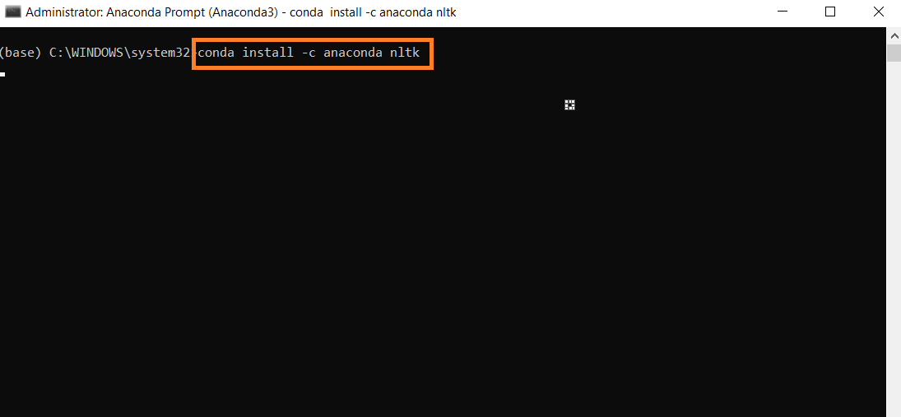

Data Set: Restaurant_Reviews.tsv (Tab Separated File)

Import Libraries
import numpy as np
import matplotlib.pyplot as plt
import pandas as pd
import os

Import Data Set
os.chdir('C:\\Noble\\Training\\Course Content\\NLP\\Training\\Data Set\\')
print (os.getcwd())
# \t – for tab separated
# quoting = 3 – ignore “” from processing
dataset = pd.read_csv('Restaurant_Reviews.tsv', delimiter = '\t', quoting = 3)
display (dataset)

Get one row from data set – example line 5
print (dataset['Review'][5])

To Print / View all stop words
import nltk # for stop words
from nltk.corpus import stopwords
nltk.download('stopwords')
all_stopwords = stopwords.words('english')
print (all_stopwords)

Cleaning the Data Set
import re
# re – Regular expression - https://docs.python.org/3/library/re.html
import nltk # for stop words
nltk.download('stopwords') # importing all stopwords
from nltk.corpus import stopwords
from nltk.stem.porter import PorterStemmer # For applying steming in the dataset , to get the root of the word
corpus = [] # create a list to store all cleaned words
for i in range(0, 1000):
# dataset['Review'][i] - source data to prcess - i th record in the data
review = re.sub('[^a-zA-Z]', ' ', dataset['Review'][i]) # Replace punctuations with space, other than letters replace with space
review = review.lower()
review = review.split() # split into different words
ps = PorterStemmer() # get root words
all_stopwords = stopwords.words('english') # get english stop words
all_stopwords.remove('not') # Remove “not” from stop words
review = [ps.stem(word) for word in review if not word in set(all_stopwords)]
review = ' '.join(review)
corpus.append(review)

Print Corpus
print (corpus)

To check Number of Distinct Words
from sklearn.feature_extraction.text import CountVectorizer
cv = CountVectorizer() # 1500 is decided by statement len(X[0]). Fist execute without max features
X = cv.fit_transform(corpus).toarray()
print (len(X[0]))

Create a Bag of Words (tokenization)

from sklearn.feature_extraction.text import CountVectorizer
cv = CountVectorizer(max_features = 1500) # 1500 is decided by statement len(X[0]). Fist execute without max features
X = cv.fit_transform(corpus).toarray()
y = dataset.iloc[:, -1].values # this is dependent variable
print(len(X[0])) # this gives me the max_features count
print (X.shape)
print (X)
print (y)

Train Test Split
from sklearn.model_selection import train_test_split
X_train, X_test, y_train, y_test = train_test_split(X, y, test_size = 0.20, random_state = 0)

Print Size
print (X.shape)
print (X_train.shape)
print (X_test.shape)

Create Naïve Bayce Algorithms
from sklearn.naive_bayes import GaussianNB
classifier = GaussianNB()
classifier.fit(X_train, y_train)

Prediction
y_pred = classifier.predict(X_test)
print (y_pred )

Print Result Actual and Predict
print(np.concatenate((y_pred.reshape(len(y_pred),1), y_test.reshape(len(y_test),1)),1))

Confusion Matrix to print Accuracy

from sklearn.metrics import confusion_matrix, accuracy_score,classification_report
cm = confusion_matrix(y_test, y_pred)
print ('Accuracy:',accuracy_score(y_test, y_pred))
print ()
print(cm)
print (classification_report(y_test, y_pred))

Create Decision Tree Classifier

from sklearn.tree import DecisionTreeClassifier
dt= DecisionTreeClassifier()
dt.fit(X_train, y_train)
dt_pred = dt.predict(X_test)
cm = confusion_matrix(y_test,dt_pred)
print ('Accuracy:', accuracy_score(y_test,dt_pred))
print ()
print(cm)
print (classification_report (y_test,dt_pred))

Prediction with New Data

Create a list with new review

new= ['hotel not good', 'food tastier nice', 'chicken not coock properli veg not upto mark','Good Service']

Convert to Bag of words
#Create a two-dimensional array with 1500 columns

fp = cv.transform(new).toarray()
print (fp.shape)
print (fp)

Prediction

print (dt.predict(fp))

